How to use the Mass Storage Bootloader type

After the chip is programmed with the bootloader ,when you connect the board to the computer USB port and keep pressed the button USER and press and release the RESET, in few seconds it will appear a mass storage device named „Bootloader” with a file named „firmware.bin”.
You must delete the „firmware.bin” file and copy the *.bin file you want to programm.

There is special configuration nedded to compile the file you want to put on the chip.
The bootloader is 0x4000 long so your programm must start at 0x8004000:

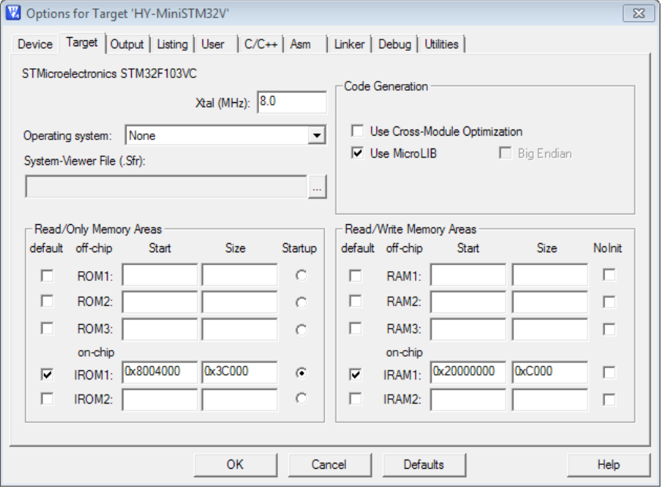

Also we must tell the compiler to generate a *.bin file:

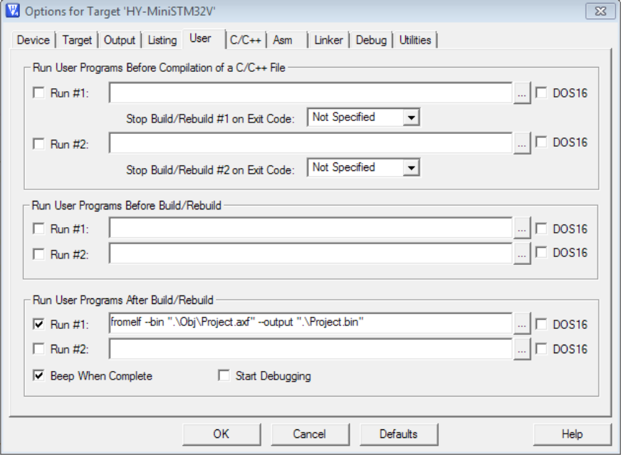

We must set the Vector Table base adress start at 0x8004000, so we put in main:
NVIC_SetVectorTable(NVIC_VectTab_FLASH, 0x4000);

